NAME: TANAKA CHANDAMARA
REG NUMBER: C24158553K
PROGRAM: BECE5
PRACTICAL: GENERATION OF EM – WAVE

Gif of OUTPUT of generated EM-WAVE:

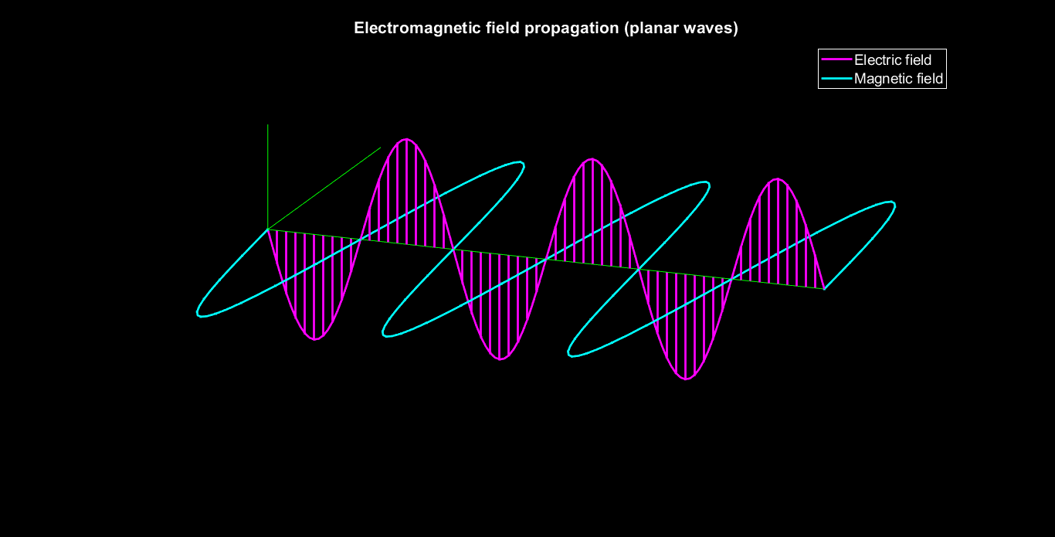

Screenshot of Matlab Code:
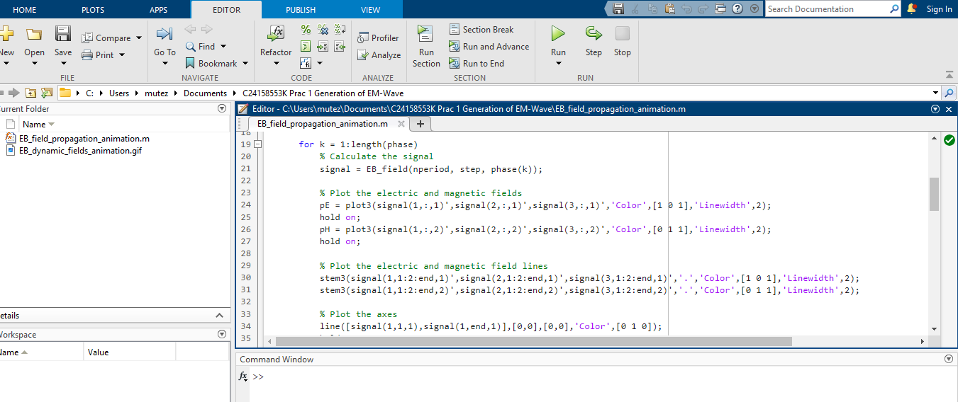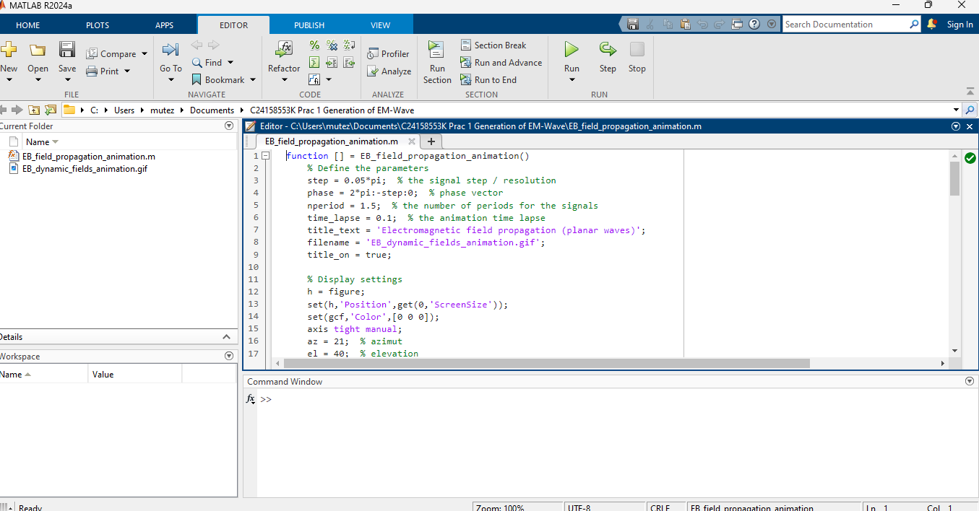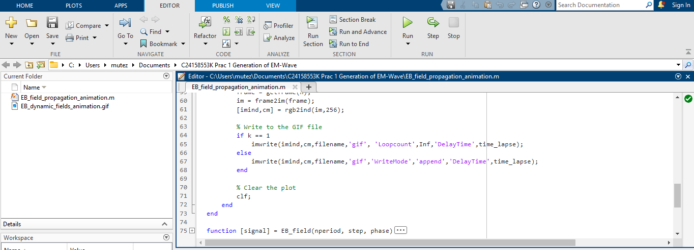

VIVA QUESTIONS:
- Electric field at a point in space is defined as the electronic force experienced by a small test charge place at that point divided by the magnitude of that test charge.

- EM waves propagate due to the mutual induction of electric and magnetic fields, governed by Maxwell’s equations.

- The speed of an electromagnetic (EM) wave depends on the medium it travels through but in vacuum or free space they travel at speed of light

- The relationship between frequency and wavelength is inversely proportional this means when frequency increases wavelength decreases and when frequency decreases wavelength increases

- The nature of an electromagnetic (EM) wave is:

Transverse wave:

EM waves consist of oscillating electric and magnetic fields that are perpendicular to each other and to the direction of wave propagation.

Does not require a medium:

Unlike sound waves, EM waves can travel through a vacuum (empty space).

Travels at the speed of light:

In a vacuum, all EM waves travel at approximately 3×1083 \times 10^8 m/s.

Produced by accelerating charges:

EM waves are generated when electric charges accelerate or change direction.

Carries energy and momentum:

EM waves can transfer energy and momentum to objects.

Obeys wave properties:

They show phenomena like reflection, refraction, diffraction, interference, and polarization.

Described by Maxwell’s equations:

These equations explain how electric and magnetic fields propagate and interact.
In short, EM waves are transverse, self-propagating waves of electric and magnetic fields that do not require a medium and travel at the speed of light.

